Bamazon Manager Code Examples:

Example of prompt options at the start:

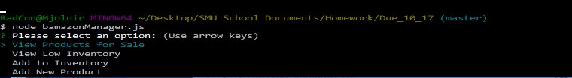

Example of "View Products for Sale" option:

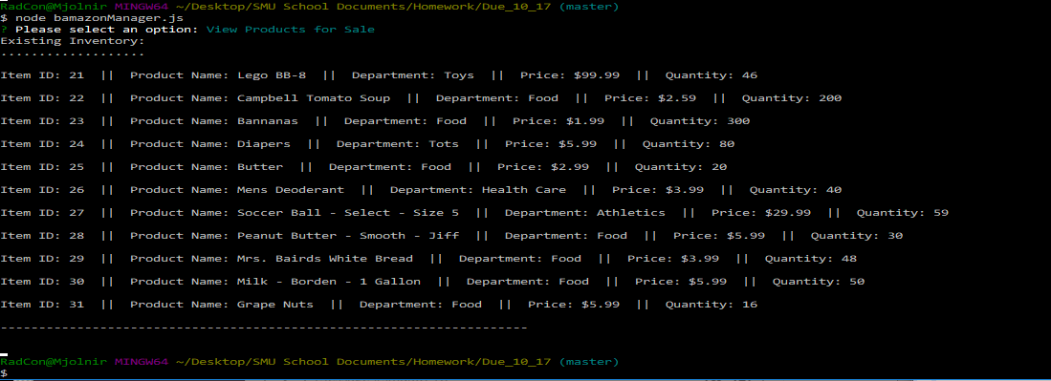

Example of "View Low Inventory" option:

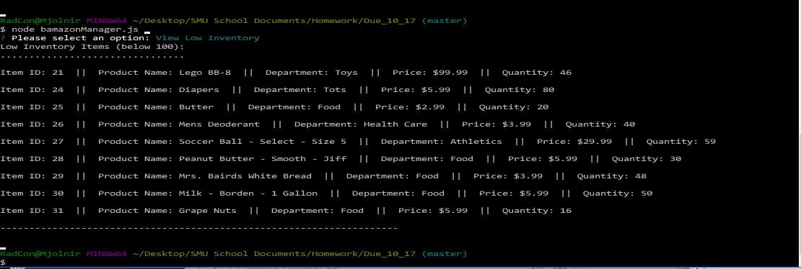

Example of "Add to Inventory" option:

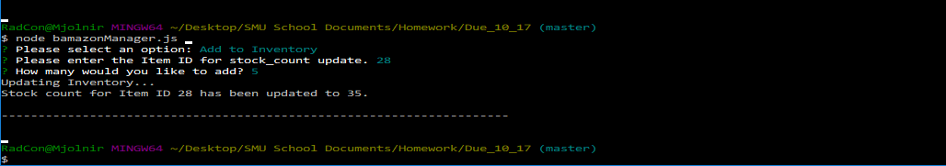

Example of "Add New Product" option:

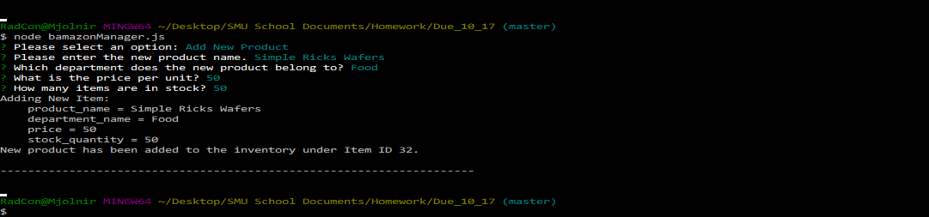

Example of a purchase with insufficient inventory in stock. Order does not complete and customer is asked to modify order:

